Blooming Paper Flowers

Make a paper flower and watch it bloom!

- Draw a paper flower or use a template.
- Decorate the flower and cut it out.
- Pour some water into a bowl and place the flower on the water.
- Watch the paper flower open.
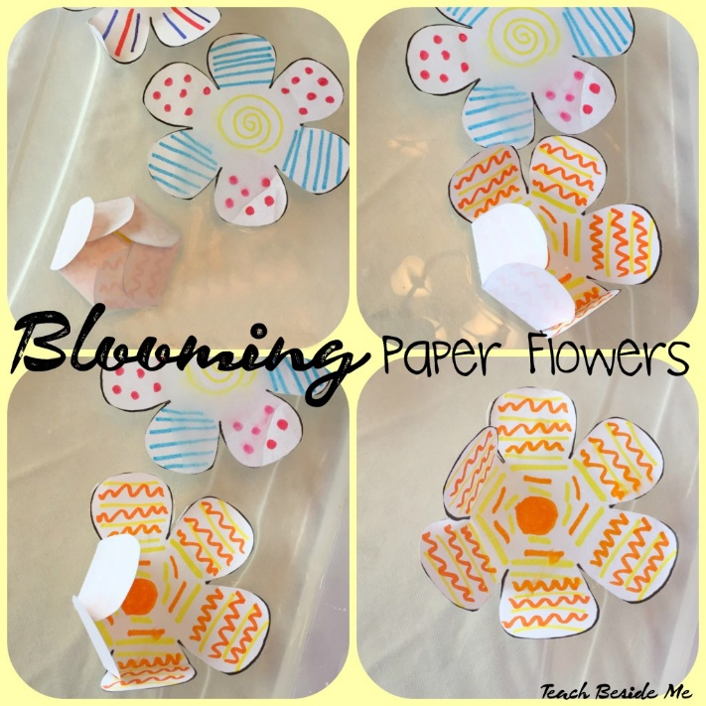

- Try using kitchen paper to make your flower. What happens?
- Try using thin card. What happens?
- Try making flowers of different sizes or with different numbers of petals.
Does it make a difference to what happens?
- Use felt tips and two or three different colours and observe the colours mixing. This may get a little messy! The flowers look fabulous once they have dried and could be used to create a work of art or a card for someone special.
Flower Template
https://teachbesideme.com/blooming-paper-flowers-experiment/
For smaller flowers, print two to a page.

What’s Happening?
The paper is made of tiny fibres pressed together. As the fibres absorb (soak up) the water, they expand and push the flower petals open.

